Pc Hardware Application
Ciora Alexandru Ștefan

1. Introduction
This project is the implementation of a PC parts shop, where you can browse through available parts, buy any amount you want and see previously placed purchases and their status. It is designed for both users and employees.

2. Implemented features
User (database access):
- Log in check (user/admin)
- Registering a new user
- Format validators for username, email, password

Order (database access):
- Placing a new order for the current user
- Seeing the user orders/every order if admin
- Updating the status of any order as admin

Part (database access):
- Base component containing common attributes
- Represents parts stored in database based on availability
- Lookup by ID or name
- Updates stock after a purchase
- Allows restocking
- Manages adding new components to the inventory

-CPU, GPU, Motherboard (database access):
- Specific attributes to each.
- Validate additional specifications for each component
- Store the additional data in the database

Input Validator:
- Helper functions to validate inputs:
  - Boolean, Strings, doubles, integers

3. GUI: JavaFX with SceneBuilder
- 1. Login and account register forms
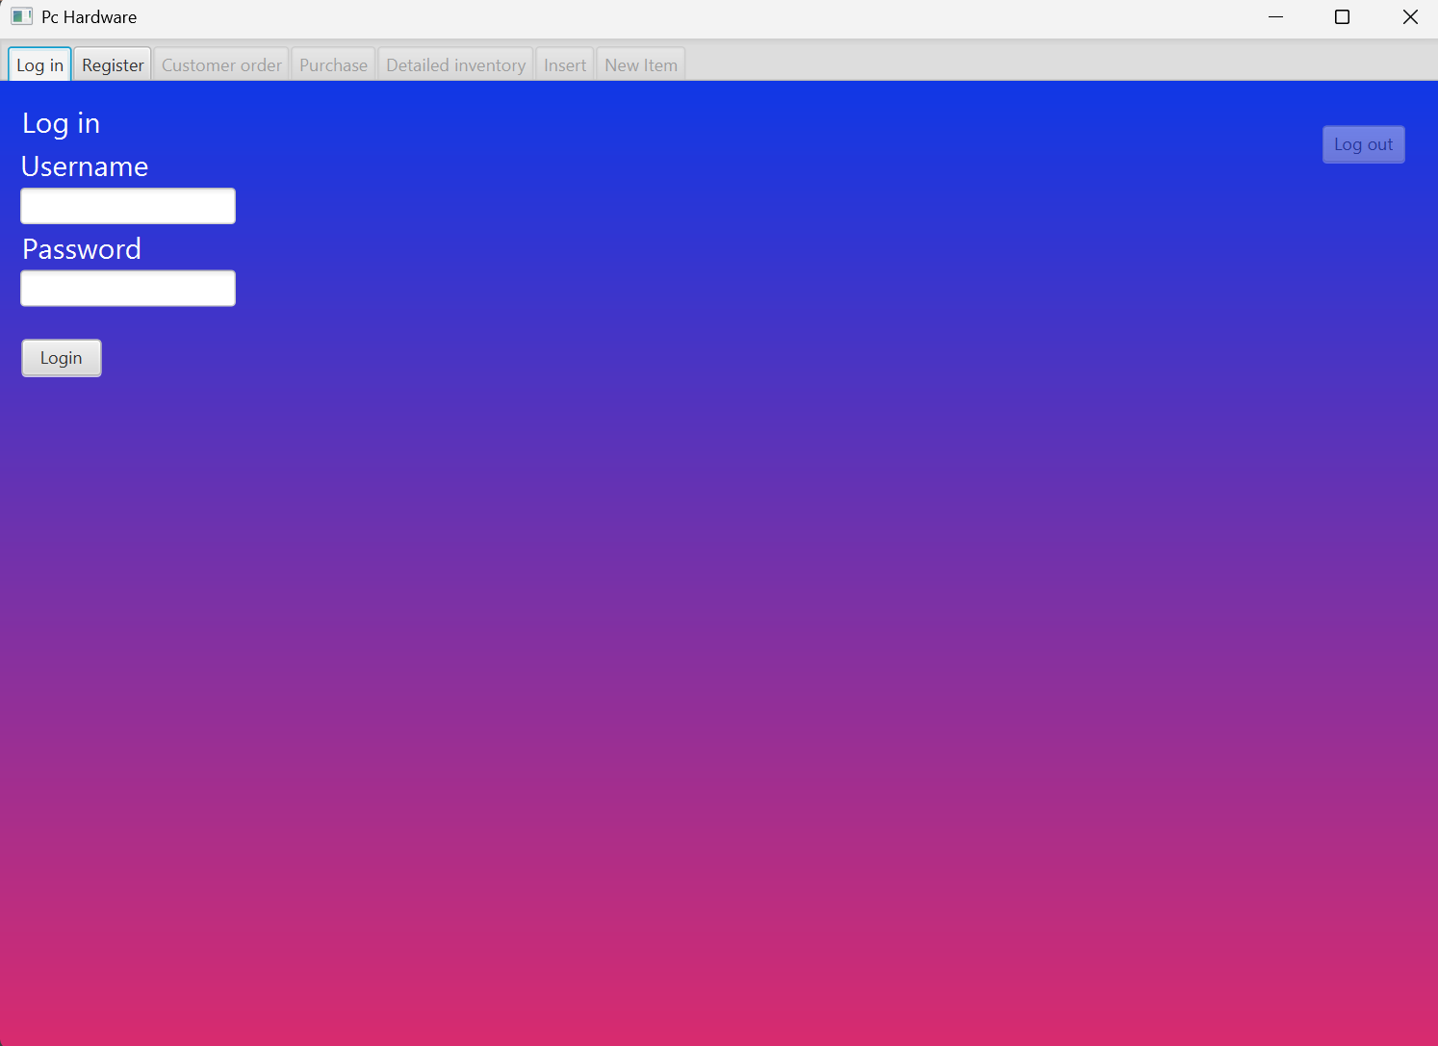
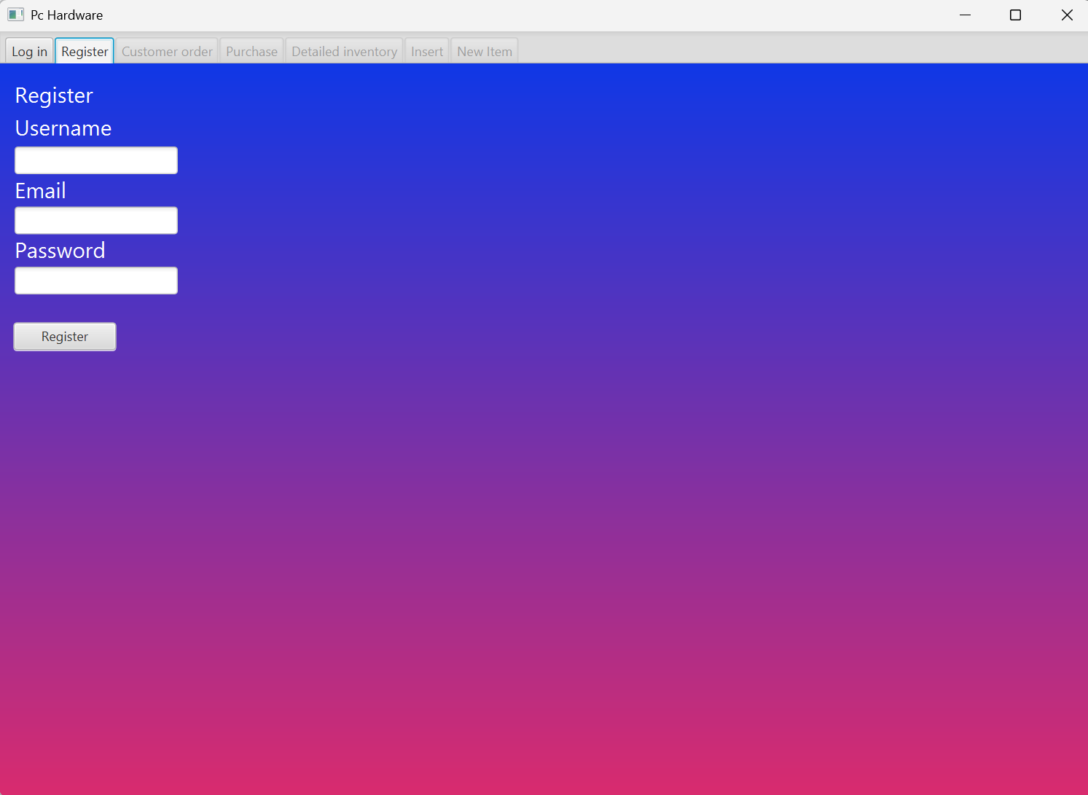
- 2. Orders:
  - The user can see his placed orders
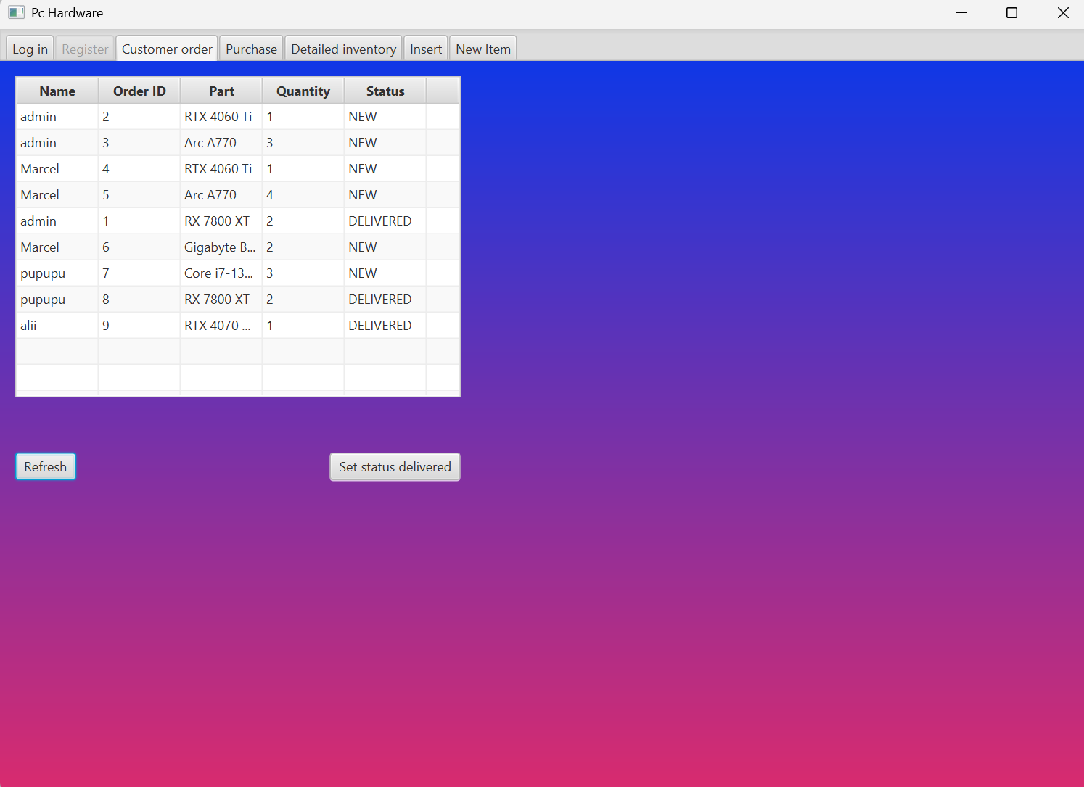
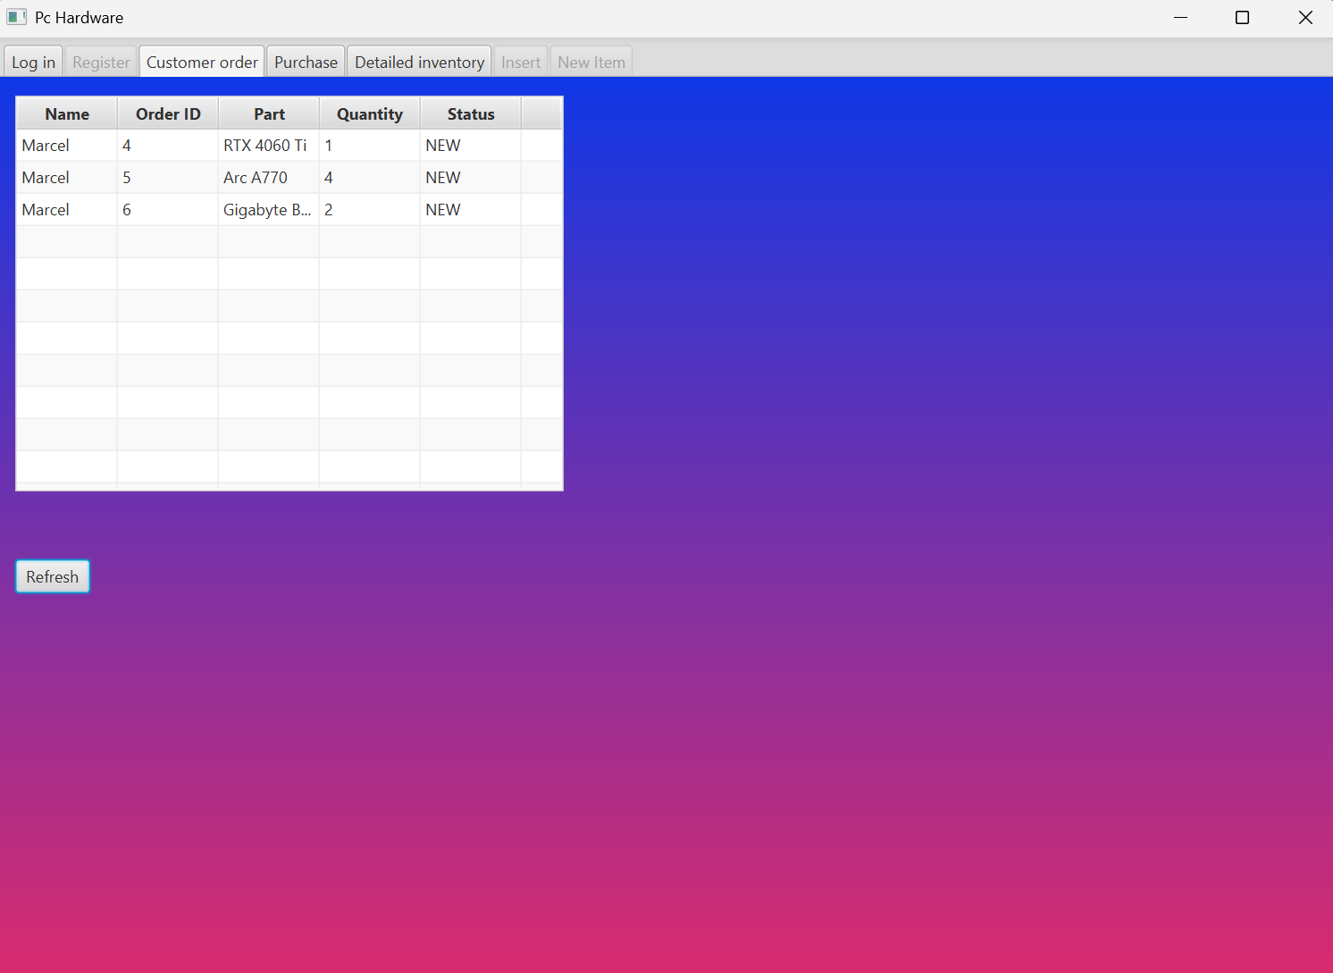
  - An admin can see every placed order and change it’s status

- 3. Product information and purchasing
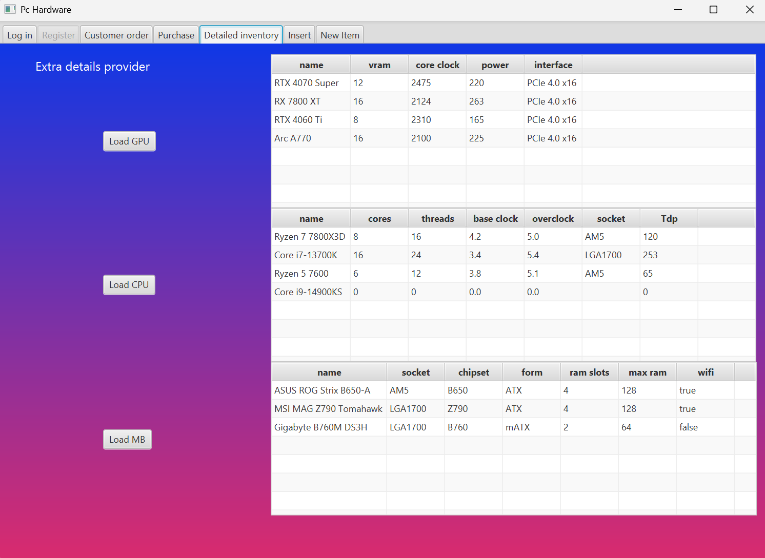
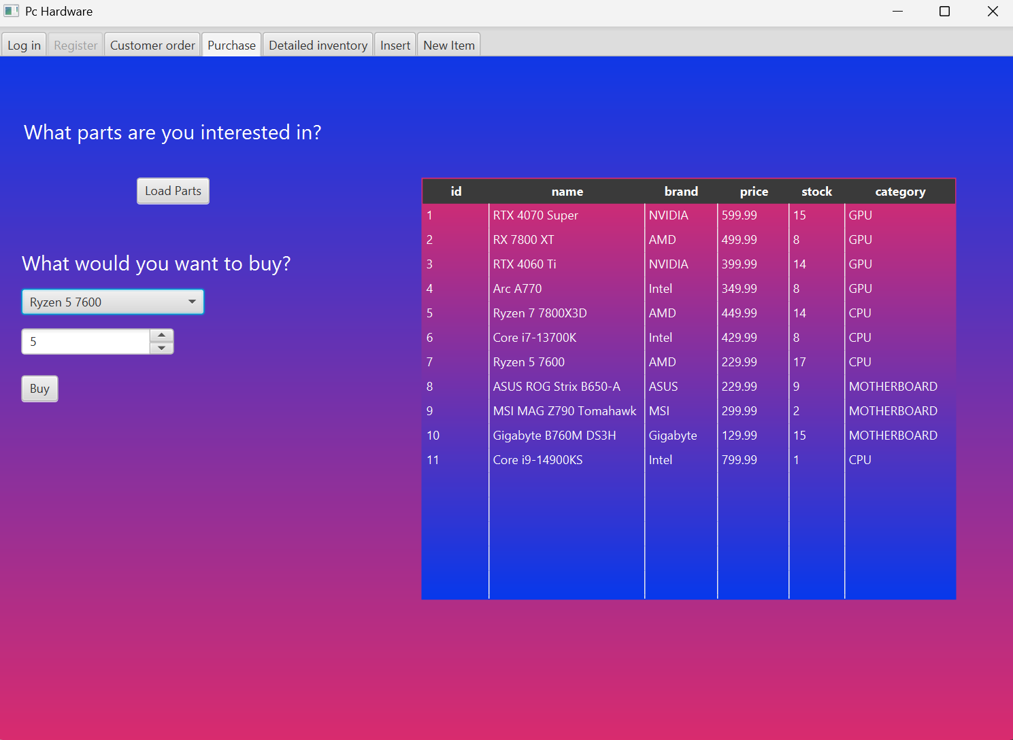
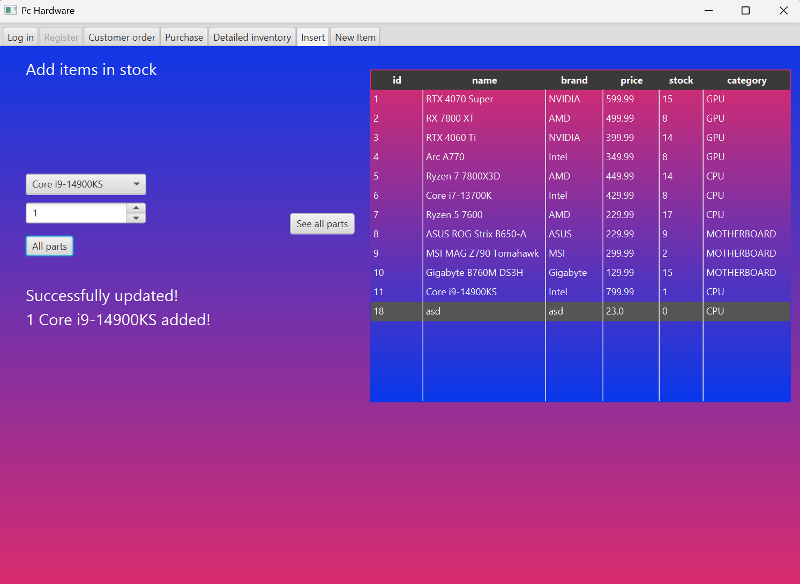
- 4. Adding products to stock and adding new items (admin only)
